A2054-Eur-Celtic-Figure-Anthropomorphic-Male-Arms Folded-Seated-Bronze-900 CE

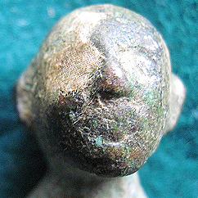

**Case no.: 4**

**Accession Number:**

**Formal Label:** Eur-Celtic-Figure-Anthropomorphic-Male-Arms Folded-Seated-Bronze-900 CE

**Display Description:**

**LC Classification:**

**Date or Time Horizon:**

**Geographical Area:**

**Map:**

**GPS coordinates:**

**Cultural Affiliation:**

**Media:**

**Dimensions:**

**Weight:**

**Condition:**

**Provenance:**

**Discussion:**

**References:**